C1HSuperTitle
C1HTitle

C1HByLine



This manual was produced using ComponentOne Doc-To-Help.™

Contents
The Darwinet™ project subversion repository local structure 1
The subversion repository structure 1
Default local file structure 1
Checking out Darwinet™ files 2
Glossary of Terms 3
Index 5

The Darwinet™ project subversion repository local structure
The Darwinet™ project assumes you follow the following guide lines when you work with sub version.

The subversion repository structure
The Darwinet™ project uses the recommended repository structure. We quote subversion manual.
“
There are some standard, recommended ways to organize a repository. Most people create a trunk directory to hold the “main line” of development, a branches directory to contain branch copies, and a tags directory to contain tag copies. If a repository holds only one project, then often people create these top-level directories:
/trunk
/branches
/tags
“
These top folders are used by the Darwinet™ project for the purposes defined by the subversion standard described above.

Default local file structure
To allow the source project to use absolute paths (accidentally or deliberately) the project is assumed to be checked out to local folder according to the following scheme.
A top folder in the repository must be checked out to a local folder with a path defined by:
c:\subversion\darwinet\<top folder>
This means specifically that the trunk (main line of development) must be checked out to c:\subversion\darwinet\trunk.

Checking out Darwinet™ files
The trunk (main line of development) must be checked out to c:\subversion\darwinet\trunk.
Using the Tortoise client this is done using the “Check out” operation. The following dialog is shown. Enter the information as described in the figure below.
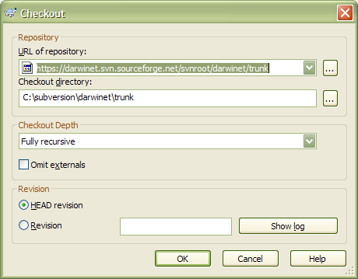

Glossary of Terms

darwinet
The name of the darwinet project. Is a combination of the words Darwin and Network. Darwin is the guy that discovered that species on earth has come to their current forms through evolution. And Network refers to the fact that the darwinet is a network that supports and promotes data and application to evolve in a manner similar to the evolution process of species.

Index
Fel! Hittade inga indexord.

